Women’s Empowerment and Panchayat
The Case of Aritar Gram Panchayat of Sikkim
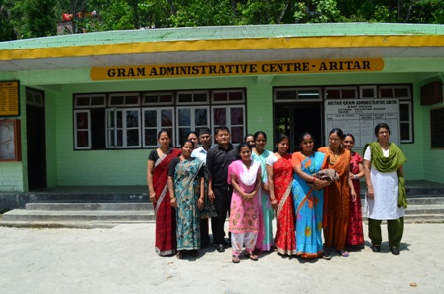
Prepared for
Ministry of Panchayati Raj, Government of India
By


Institute of Social Sciences

Cover photo:
SHG Members of Aritar GP with ISS Team

Authors

Debraj Bhattacharya
Madhulika Mitra
Buddhadeb Ghosh

Aritar Gram Panchayat
Basic Information
Aritar Gram Panchayat is located in the East Sikkim District. The Sub Division is Rongli and the Block in which the Gram Panchayat is located is Regu. Total population of the GP is 4060 out of which 2049 are male and 2011 are female. There are 749 households in the GP. The population is mostly from the Scheduled Tribes (878) and Scheduled Castes (874) and 2016 belong to Bakcward Classes. 779 persons are identified as most backward status. Only 52 persons belong to the General Category. There are 189 BPL households. 951 persons have been classified as illiterate out of the total population of 4060. There are 8 ICDS Centres, 7 Primary Schools, 2 Junior High Schools and 1 Senior Secondary School. The Gram Panchayat also has 17 Fair Price shops, 10 Cooperative Societies and 4 NGOs. There are 11 Self Help Groups.
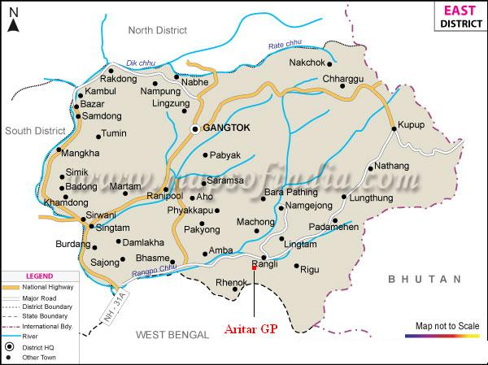
Map 1: Location of Aritar GP in East Sikkim District
Local Economy
The economy of the Gram Panchayat is primarily agrarian. The principal crops are Maize, Millet, Paddy, Buck Wheat and Wheat. Apart from these, several cash crops are also grown here such as Ginger, Cardamom and Potato. Apart from crops, the GP is also well-known for vegetables and fruits. Vegetables such as cabbage, cauliflower, tomato, Ladies Finger, Pumkin, Brinjal, Round Chillies, Beans and Bitter Gourd are grown here. The fruits that are grown here consist of Orange, Guava, Papaya, Passion Fruits, Pine-Apple, Banana, Pears and Peach.
In terms of distribution of land the situation of Aritar GP is as follows:
Table 1
Distribution of Land in Aritar GP
 |  | Landless | Marginal | Small | Medium | Large
Ward | Aritar Maneydara | 32.67 | 58.00 | 4.00 | 4.00 | 1.33
Ward | Gumpa Simana | 21.70 | 66.04 | 4.72 | 6.60 | 0.94
Ward | Kingstone | 26.77 | 65.35 | 3.15 | 4.72 | 0.00
Ward | Kutitar | 27.97 | 61.02 | 8.47 | 2.54 | 0.00
Ward | Middle Aritar | 25.24 | 49.51 | 12.62 | 12.62 | 0.00
Ward | Pradhan Gaon | 20.45 | 70.45 | 6.82 | 2.27 | 0.00
Religion | Buddhist | 17.79 | 68.10 | 4.91 | 7.98 | 1.23
Religion | Hindu | 27.11 | 60.22 | 7.56 | 4.89 | 0.22
Religion | Christian | 41.46 | 56.10 | 2.44 | 0.00 | 0.00
Religion | Others | 39.47 | 52.63 | 2.63 | 5.26 | 0.00
Quintile | Poorest | 40.40 | 52.98 | 4.64 | 1.99 | 0.00
Quintile | Poor | 29.60 | 64.80 | 1.60 | 4.00 | 0.00
Quintile | Marginal | 32.39 | 59.15 | 4.93 | 3.52 | 0.00
Quintile | Rich | 16.91 | 66.91 | 7.35 | 7.35 | 1.47
Quintile | Richest | 11.59 | 64.49 | 13.04 | 10.14 | 0.72
Total |  | 26.45 | 61.42 | 6.36 | 5.35 | 0.43
Source: Village Development Action Plan
As can be seen from the above table more than one-fourth of the population are landless and more than sixty-one percent of the population are categorized as “marginal” i.e. they have very little land. Thus most of the people living in the GP either do not have any land or have very little land.
The GP also has a growing tourism industry which has resulted in several small and medium sized hotels which caters to tourists visiting the tourist spots of the region. Apart from tourism, however, there is no important industry within the GP area.
The average per capita income of the GP in 2005-06 was Rs 20746.12. The average per capita income of the poorest quintile was Rs 6873.25 and for the richest quintile the per capita income was Rs 44021.62. It is reported that there are 443 unemployed persons among the residents of the GP.

Profile of the Gram Panchayat:
Aritar GP has 6 wards with six members. Five members are from Sikkim Democratic Front and one member stood as an independent candidate. The President of the Gram Panchayat is Mr. Dhiren Gurung, Vice-President is Mrs Uma Neopaney and the Secretary is Mr. N.B. Chetri. It may be mentioned here Sikkim has a system where the Secretary is also an elected member of the Gram Panchayat. The Gram Panchayat has 5 staffs in addition to the members. The office is a beautifully built structure with computer facility, conference room and a small library. It also has a large courtyard where Gram Sabha meetings are held.
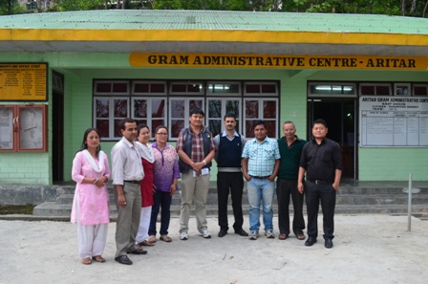
Photograph 2: Members and Staff of Aritar GP

Important interventions of Aritar Gram Panchayat:
- Promotion of Women Empowerment through Self-Help-Groups:
Since 2008, Aritar GP has focused on empowerment of women through the formation of Self-Help-Groups. In 2008 State Rural Development Agency of Sikkim organized a workshop where the GP President Mr.Dhiren Gurung was exposed to the idea of Self-Help-Groups. The GP functionaries also made exposure visits to Kerala in order to see the Kudumbashree programme of the state. Mr Gurung, the Gp Ptresident, then took up the idea enthusiastically in his GP. After discussion with his GP members and staff as well as local NGOs it was decided that in every ward at least one SHG would be formed which would become a unit of development for the women of the GP. Apart from NGOs and SRDA the GP was also helped by the Corporate Social Responsibility wing of Gati Infrastructure. A plan was developed to financially support the SHGs. It was decided that if a SHG saved Rs 10,000 they would get a grant of Rs 5000.
The first step was to train local women on how to form SHGs. Training on this was provided by SRDA, Gati Infrastructure and state level CSO Youth Development Society of Sikkim. In this way 11 SHGs had been formed in the 6 wards of the GP. Once the SHGs were formed with each SHG having a minimum of ten members, they were given vocational training on (a) how to make Phenyl and package it in a professional manner (b) how to manufacture decorative candles (c) how to make Toys for children, (d) how to cultivate mushroom, (e) how to cultivate ginger, which is an important cash crop and (f) how to prepare organic spices of different kinds.

The Stories of two SHGs
The research team had a detailed discussion with two SHGs in Aritar GP regarding their experiences. Himali SHG was formed in 2010. The group leader had some previous knowledge of potato chips making. Some of the SHG members were associated with the Group leaders earlier regarding this. The Gram Panchayat gave them the idea that it would be useful for them to get various kinds of benefits such as subsidy and marketing if they form a SHG. So the women came together to form a SHG. The GP in collaboration with state level CSO Sikkim Youth Development Society provided them basic training on how to form and run a SHG. They opened an account in the local CISCO bank. They decided to save Rs 50 per person per month. After two years they received a loan of Rs 50,000 from CISCO bank. The loan was taken to buy professionally produced packaging material for the organic spices that they had started to manufacture. Under the ATMA scheme of the Agriculture Department the Group got a popcorn making machine with the help of which they have started to manufacture popcorns.
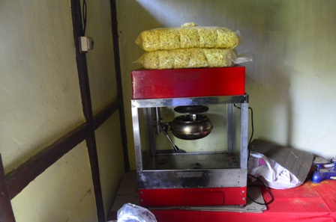
Photograph 3: Machine for Preparing Popcorn Owned by Himali SHG
The products that the Group makes are sold locally in various shops and small hotels. Their organic spices are very much in demand. The research team tasted the popcorn that was being made and the bought samples of organic spices. The spices were professionally packaged and tasted as good as any other marketed product and did not look like amateurish products made by Government supported SHGs. The Group leader explained that the products are sold both door-to-door as well as in the local shops. Now, they are supplying their products in five hotels. The products are also sold in the local fairs and religious festivals.
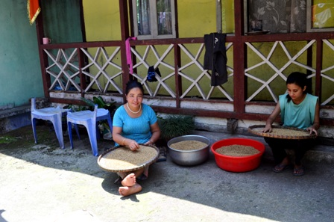
Photograph 4: Members of Himali SHG Preparing Spices

The economics of the activity of the group per month as explained by the members is as follows:
Table 2
Approximate Monthly Income and Expenditure of Himali SHG
Cost | Sale | Earning
Raw Materials – Rs. 10,000  Other Costs (transport, electricity, packaging etc.) – Rs. 5,000 – Rs. 6,000 | Sale – Rs. 21,000 | Rs. 5,000 – 6,000
Source: Himali SHG

In this way the Group earns about Rs 5,000 – 6,000 per month which is further used for their business development and profits are shared among the members every 3-4 months. The amount is not same for all members. Those who work on machines receive Rs. 3,000 – Rs. 3,500 each time while the members involved in marketing activities get Rs. 3,000 each time. Those who are involved for in – house works like making the seeds dry etc. receive Rs. 1,500 to Rs. 2,000 each time. The Group also provides loans to its members for medical emergencies and for purchase of livestock.
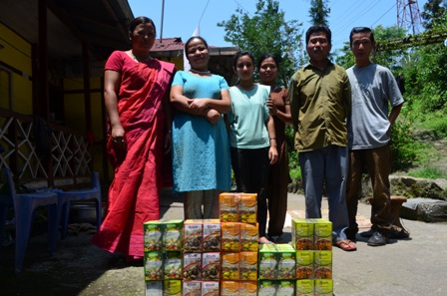
Photograph 5: Members of Himali SHG with their Products
The Narishakti Group was formed in 2007-08. The group consists of women who were all housewives previously and had no source of income of their own. They save Rs 30 per person per month. Since all the members were housewives they were good at cooking, a skill that they acquired through their upbringing in traditional families. They decided to use these skills to run High School Canteen and also provide catering services in various local functions and celebrations. They also received training in preparation of phenyl, candles, and cultivation of cash crops like ginger and turmeric. The research team saw examples of the phenyl that is manufactured and sold by the Group. The cost of manufacturing a bottle of phenyl is Rs 17.50 and it takes roughly Rs 10 per bottle to market the product. The sale price of a bottle of phenyl is Rs 40/- which gives the group a profit of Rs 13 per bottle. Between January and May 2013 2000 such bottles of phenyl has been sold. The phenyl bottle was smartly packaged and did not have any stamp of amateurishness that is often seen among SHG-made products. Like the Himali Group the Narishakti group gives loans to its members for medical and other household needs.

Outcome of the initiatives
What has been the experience of the two groups in terms of empowerment? The women, who spoke confidently with the research team, explained that now they are able to earn their own money and do not need to depend on their husbands. Participation in Gram Sabha has increased significantly. When the group members are participating in the Gram Sabha, they try to motivate village women to follow them. Now, almost 70 percent women are participating in the Gram Sabha and they are able to voice their own opinion in public forums. The groups not only participate in the Gram Sabha but also participate in discussion and register their complaints. When asked to give an example of the kind of problems they pointed out in the meetings, the women of the Narishakti Group said that they had complained about the menace being caused by monkeys in the agricultural fields and the members of the groups also said that they are yet to receive any solution from the Gram Panchayat. They had the confidence to say this in front of the Gram Panchayat officials. The SHG members also visit GP office frequently for health camp or for attending other meetings which they did not practice earlier. The women of the Self Help Groups have also acquired the confidence to visit banks and negotiate loans with the Bank managers who are mostly male. Himali Group members proudly said that they had already repaid Rs 31,000 of the loan that they had taken and also complained about the increase in interest rate that the bank had recently enforced. Earlier, only the President and the Secretary of this group were literate but at present, all the members can sign their names.
The groups also participate in social work. The Narishakti group, the research team found, were also working as volunteers in the local CSO, Navjagriti Sangh, and participating in all their social work. Himali Group, as informed, works with gram panchayat in sanitation campaigning. It also distributes juice and tea in Hanuman Jayanti and other ritual functions.
Explaining the difference that SHG made in the lives of group members, the Himali Group leader feels that now they have a new identity and a new social status whereas previously they were only wives of some men. Now they can take decisions in their household also. Even among the relatives, they have now some recognition. This is remarkable given the fact that only a few years back they were nothing more than housewives.
The Self Help Groups of the Gram Panchayat are provided knowledge and practical training on various issues. The training programme of one such workshop is given below:
Table 3
Schedule of a Training Progrmme Imparted to SHG Members
Date | 10 - 10:30 | 10:30 – 11:30 | 11:45 – 12:45 | 12:45 – 14:00 | 14:00 – 15: 00 | 15:15 – 16:15
29.03.12 | Inauguration. Chief Guest: Smt. Asha Bhushal, Upadhyaksha, East District Zilla Panchayat, Govt. of Sikkim |  |  | Lunch | Health, Hygiene and Communicable Diseases | Livestock Management and Development
30.03.12 | Interactive Session | Women Empowerment |  | Lunch | Nutritious Diet and Neo-natal Care
31.03.12 | Interactive Session | Mushroom Growing and Pickle Making |  | Lunch | Panchayati raj system
01.04.12 | Interactive Session | Soft Toys Making and Candle Designing |  | Lunch | Bamboo crafts: Designing and Making of bamboo artifacts
02.04.12 | Interactive Session | Pickle Juice and Sauce making |  | Lunch | Organic Farming
03.04.12 | Interactive Session | Perfume, Candle and Phenyl making |  | Lunch | Political, Social, Economic Rights and Legal Issues of women
04.04.12 | Interactive Session | AIDS awareness |  | Lunch | Drug Abuse | Valedictory Ceremony
Source: Aritar GP

- Experimentation with Decentralized Planning
Aritar GP is a pioneer in Sikkim in developing a model of decentralized planning for the state. For this the GP received support from the Swiss Agency for Development and Cooperation (SDC). This experiment was started in 2008 under the supervision of a Swiss Consultant. The following steps were taken for the purpose of completing the decentralized planning process:
- The first step of this process was to carry out an elaborate household level survey to get the necessary data for planning. For this the GP selected 20 unemployed youth as enumerators. The youths were trained and supported in the process by the local CSO, Nava Jagriti Sangh. The format for data collection was developed by the State Government in collaboration with the SDC.
- The data was then analyzed through SPSS and transferred to GIS maps through ArcGIS.
- Once the data was collected it was validated through a workshop in which the GP functionaries, the BDO, the officials of various line departments, local school teachers participated. The validated data was uploaded on the net.
- Once the data was validated, the problems faced by each ward were analyzed. The following reasons for poverty in the GP was found – (i) under productivity of land due to lack of proper irrigation systems; (ii) Landlessness and near landlessness; (iii) Households headed by old aged persons, widowed/separated women and disabled individuals; (iv) Failure of cash crops like cardamom and ginger; (v) lack of industrialization opportunities as well as lack of skills in the non-farm sector; (vi) iodine deficiency especially in the Kuttiar ward.
- This was followed by a budget analysis and formulation of a plan through a consultative process.
This model plan was handed over to SDC for wider replication across the state. Government of Sikkim is currently considering the replication of the planning model across the state.
- GP-CSO collaboration:
Aritar Gram Panchayat has built a successful model of collaboration with local Civil Society Organisations. A local CSO, Nava Jagriti Sangh, whose Director, Mr. Subhash Dahal, was himself a member of the Gram Panchayat between 1997 and 2002 and was the President during 2001-2002. The CSO and the Gram Panchayat works together to organize Gram Sabhas, form Self Help Groups, plantation of trees, organization of different kinds of awareness programmes, implementation of Total Sanitation Campaign, etc. The CSO also helps in report writing and Economic Census. For the purpose of Social Audit of MGNREGS the Gram Panchayat has partnered with a State Level CSO – Sikkim Voluntary Health Association. For promotion of organic farming, as mentioned in the next section, the GP has collaborated with a CSO named Amar Jyoti.
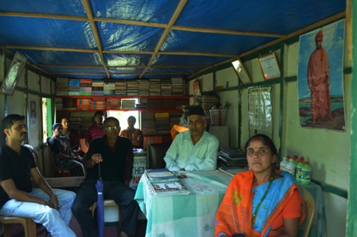
Photograph 6: Office of Nava Jagriti Sangh
During our field work we found that there is a close relationship between the members of the Gram Panchayat, the local CSO Nava Jagriti Sangh and the Self Help Group. The Self Help Group members also work as volunteers for the local CSO. While being distinct entities the members of the GP, the CSO and the SHG form an informal group which meets regularly and carry out various development activities. The distinction between them exists formally but functionally and socially they are very close.
- Promotion of Organic Farming
Recently Sikkim has taken the decision to promote organic farming. Aritar Gram Panchayat has enthusiastically taken up the initiative to promote organic farming within the Gram Panchayat. Accordingly in each ward a farmers’ group has been formed. In each group there are a minimum of 10 farmers. The formation of the farmers groups was facilitated by a local NGO, Samajik Seva Sanghstha in collaboration with the Gram Panchayat. The programme has been also supported by NABARD. A support of Rs 5000/- per group has been provided and another NGO, Amar Jyoti, has provided training to the farmers on organic farming. The training was facilitated by the Gram Panchayat. The farmers have also been provided seeds for horticulture. Aritar Gram Panchayat has set itself a goal of making the Gram Panchayat fully organic by 2015.
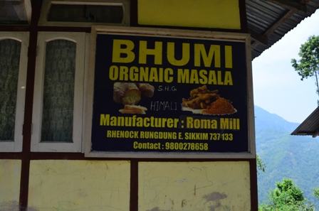
Photograph 7: Organic Masala Manufactured by the SHGs
In course of our group discussion on the shift towards organic farming we found that the farmers and the Gram Panchayat members admitted that in the short run there could be some problems. Productivity is likely to go down and prices of organic products are much more than products which use chemical fertilizer. However they were of the opinion that in the medium and long term this will be beneficial as the cost of production under organic method of farming is much less and it helps rejuvenate the soil. If successful marketing can be done, then organic vegetables can fetch substantially more income than the vegetables which use chemical fertilizers.
- Promotion of tourism
Since Aritar GP is situated in a picturesque location, the GP has taken initiatives to promote the local tourism industry. The tourism industry is an important source of livelihood for the local youth many of whom are unemployed in the absence of industries in the locality. The GP has selected 20 unemployed youth and has sent the youths for training to be given by the Tourism department. The training course is of one month duration. Following this training the youths are given a grant of Rs 7.5 lakhs. This fund is to be utilized for building purposes according to specific government norms regarding toilets, kitchen etc. When the beneficiary has completed the construction and the GP is satisfied regarding the quality of the construction, the beneficiary is given a license for “Home Stay” which is the name for small hotels which are attached to the residence. When we made our field visit the beneficiaries were constructing the buildings. Aritar GP has also facilitated the Tourism festival in 2011 which has helped to attract tourists to this part of Sikkim.

- Transparency in MGNREGS
In order to increase transparency in the process of implementation of MGNREGS certain innovations have been made by Aritar GP. At the ward level a Contractor Committee has been formed. This committee is responsible for the selection of the Contractors for those MGNREGS works for which Contractors can be engaged.. For transparency in the wage employment process social audits are done regularly by the Social Audit-cum-Vigilance Committee which is constituted by the Gram Sabha.
- Special Support to BPL families
Within its limited means Aritar GP has taken certain steps to support families that are below the Poverty Line. Such efforts include (a) support regarding the cultivation of cash crops such as mushroom, ginger and potato, (b) support related to banana cultivation and floriculture, (c) such households have been provided training on poultry farming. They have also been provided with improved seeds, farming equipment, manure and improved seeds partly free of cost and partly subsidized. BPL farmers have also been helped financially in case of crop failure due to natural calamity and cash awards have been given to progressive farmers and meritorious students. The GP has also helped BPL families in case of medical emergencies. This is in addition to the implementation of various state and centrally sponsored schemes aimed at poverty alleviation. For example under MGNREGS the following activities were taken up – (a) minor irrigation channel, (b) rural connectivity, (c) building of protection wall to avoid accidents, (d) harvesting tank for rainwater harvesting, etc. All these activities are aimed at supporting the poor people to lead a better life.

Replicability:
The success of Aritar GP has inspired the neighbouring GP of Dolapchand who has sought help of the former for setting up of office, maintenance of records and documentation of their work. Aritar GP’s success is also significant as it is not a “one-man-show” under a charismatic and exceptional leadership which cannot be replicated easily. It is the work of ordinary Gram Panchayat representatives and employees along with small local NGOs. Hence it is possible to replicate their achievements.

Some unique characteristics of Aritar

Persons who interacted with the Research Team

1. Dhiren Gurung – President, Aritar GP
2. Member Secretary, Aritar GP
3. Other Members, Aritar GP
4. Mr. Subhash Dahal, Dirctor, Nava Jagriti Sangh
5. Members of Himali SHG
6. Members of Narishakti SHG

The representatives and key employees of the GP work in close collaboration with a local NGO whose Director is a former GP President. One can say that this is an informal group that carries out development work in collaboration with the GP. In practical terms the GP and the NGO can hardly be distinguished as separate entities although they are different formally. Other support came from the state government.

